**TDD-PTM-CF170SS 17’’ Stainless Steel Closed Frame (Desktop / Wall Mount) PCAP Touch Monitors**

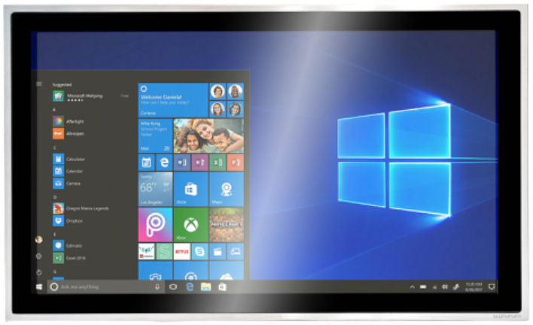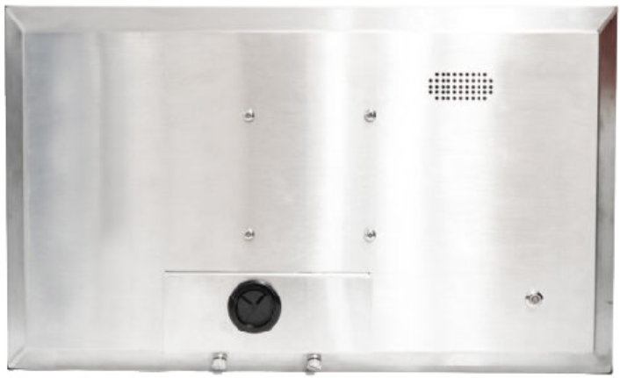

**Overview** The **TDD** **Touch Monitors** include **Standard**, **Industrial** (**Open Frame** **Bezel-free** | **Rear Mount**, **Panel Mount**, **Closed Frame**), **Outdoor**, **Waterproof**, **Stainless Steel**, **Marine**, **Curved**, **Desktop POS**, **Commercial Displays**, **Medical** and **Custom** types, delivers an industrial, reliable and cost-effective solution with outstanding image clarity & accurate touch response for OEMs & systems integrators. 7-98’’ sizes with rugged bezel, flat structure, high durability and versatility for Kiosks applications from Self-service, Automated Parking, Industrial Automation, Outdoor Control, Healthcare to Gaming. **Features** ● Touch thru glass (with **Anti-mist Optical Bonding**) enabled with PCAP supports thickness up to 5mm, **IP65 (front)**  ● Embedded design with **Rugged and Easy to Clean 304 Stainless Steel Enclosure & Full Metal Jacket**  ● **Designed for kitchen** **with** **Liquid, grease & food resistant**, flexible mounting in any table, kiosk, or cabinet design  **Panel**

|  |  |
| --- | --- |
| Diagonal Size | 17"(4:3), 43cm, Active matrix TFT LCD (LED) |
| Active Area (mm) | 337.92 mm x 270.336 mm |
| Resolution | 1280 x 1024 |
| Viewing Angle | Horizontal: 89° or 178° total / Vertical: 89° or 178° total |
| Number of Colors | 16.7 million |
| Brightness (typical) | 250 nits |
| Response Time-total | 30 (Typ.)(Tr+Td) ms |
| Contrast Ratio | 1000:1 |
| Input Video Frequency | Horizontal: 30 - 60 KHz / Vertical: 50 - 75 Hz |

**Touch**

|  |  |
| --- | --- |
| Touch Technology | PCAP (Projected Capacitive) - 10 Touch Capacity |
| Surface Treatment | Water, Dust & Vandal proof; **Optional**: Anti-glare, Anti-fingerprint, Anti-smudge, Anti-bacterial |
| Supported OS | Windows / Android / Linux / Mac |

**Interfaces / Connectors / Controls**

|  |  |
| --- | --- |
| Video Interfaces | VGA x1 / HDMI x1 / DVI x1 (opt.) / Display Port x1 (opt.) / USB x1 for Touch; HDCP: Yes |
| Connectors & Controls | Audio Mini jack x1 / DC x1; 5 OSD buttons |

**Power** Supply / Consumption: 100-240 VAC / 12VDC +/- 5%; 20W typical, 1.5W sleep, 0.5W off

|  |  |
| --- | --- |
| **Mechanical** | Product Dimensions: 397.2 x 332.5 x 40mm / Weight (Unpacked / Packed): 6.85 / 7.6 kg  Box Dimensions: 450 x 160 x 390mm / VESA Mounting: 75 x 75 / 100 x 100mm |
| **Environmental** | Operating / Storage Temperature: -10°C to 50°C / -20°C to 60°C |
| **Accessories** | Power adapter / cable, HDMI / VGA / Touch USB cable, wall mount brackets w/screws (opt.) |
| **Others** | MTBF / Warranty / Enclosure Color: 50,000 hours demonstrated / 1-year / silver  Ready for Use: 24/7 |

* **TDD** ([**www.tddtouch.com**](http://www.tddtouch.com), [**sales@tddtouch.com**](mailto:sales@tddtouch.com)) reserves the right to change specifications without prior notice.